OGDEN’S ENCYCLOPEDIA OF RADIO HORROR—“J” Copyright © 2010 Vanished Voices OTR
`

J 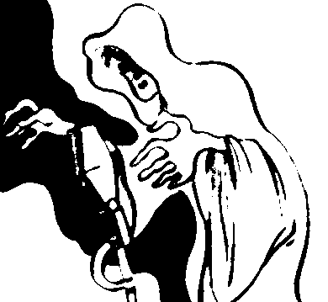

J. B. MACABRE’S MACABREOTORIUM
[RADIO-SERIES]
[MACABRE, J. B. “The Bat Takes Flight: Vampires on Air.” The Complete Vampire Companion. New York: Macmillan, 1994.]
“J. B. Macabre’s Macabreotorium took to the airwaves of New York City on March 1, 1988, on radio station WBAI. It took advantage of the new digital technology, the binaural recording process, and a glut of aspiring actors living in the Big Apple to offer up tales of the weird and macabre. The program aired for three and a half years. Among the many episodes was a tale of a modern-day vampire, ‘Bad Blood.’ The plot placed an aspiring young black doctor, who had developed a vaccine that could arrest the course of AIDS but not cure it, up against a rich and powerful vampire who was being destroyed by the disease. While the plot employed traditional vampire themes in relation to the myth, the characters were motivated by modern convictions, all taken to extremes in a climax that became a paradox. Reaction to the program was so great that the station manager rebroadcast the program the next day. For the next year and a half, J. B. Macabre’s Macabreotorium was aired twice a month.”

[PROGRAM INFORMATION]
ORIGINATION: WBAI, New York City, New York (Pacifica).
DURATION: March 1, 1988-1991.
PERSONNEL: J. B. Macabre.
EXTANT RECORDINGS: Unknown.

JOURNEY INTO FEAR
For those of us who are Peter Lorre fans, we can never get enough of that wonderful actor. So this is, yes, the Peter Lorre series that, sadly, never was. Lorre was riding a crest of popularity in 1944 with a starring role in the Warner Brothers film Mask of Dimitrios, plus a strong supporting presence in Frank Capra’s Arsenic and Old Lace (in the part of Dr. Einstein, which radio actor Edgar Stehli had created in the play’s original Broadway incarnation). He was also making numerous radio appearances, both war-effort pleas and his usual spookery, including several guest spots on Inner Sanctum Mysteries and Creeps by Night.
“Peter Lorre is being offered,” it was announced in the June 28, 1944 issue of Variety, “in a package thriller, ‘Journey Into Fear,’ as a half-hour evening show on a sliding scale price. Asking price is $2,000 for the first 13 weeks, $4,000 for the next 39, $4,500 for the next 52 and $5,000 per thereafter. Session is written and directed by Norman Winters and is packaged by Dell Peters.”

THE JUDGE’S HOUSE

THE MAN IN BLACK (LIGHT PROGRAMME, LONDON)
[Monday—8:30-9:00 PM]
February 28, 1949 “The Judge’s House”
PERSONNEL: John Keir Cross (scriptwriter), David H. Godfrey (producer), Martin C. Webster (producer).

